305

Date of foundation - **October 4,1916.**

Until 1917 the city was known as Romanov-on-Murman.

Murmansk has the honorary rank of the hero-city and was awarded with the

Order of the Red Banner of Labour,

the First Class Order of the Patriotic

War and «Gold Star» Medal,

«Sword of Victory» devoted to the 70th anniversary of the Victory in the Great Patriotic war and 30th anniversary of the hero-city rank allocation.

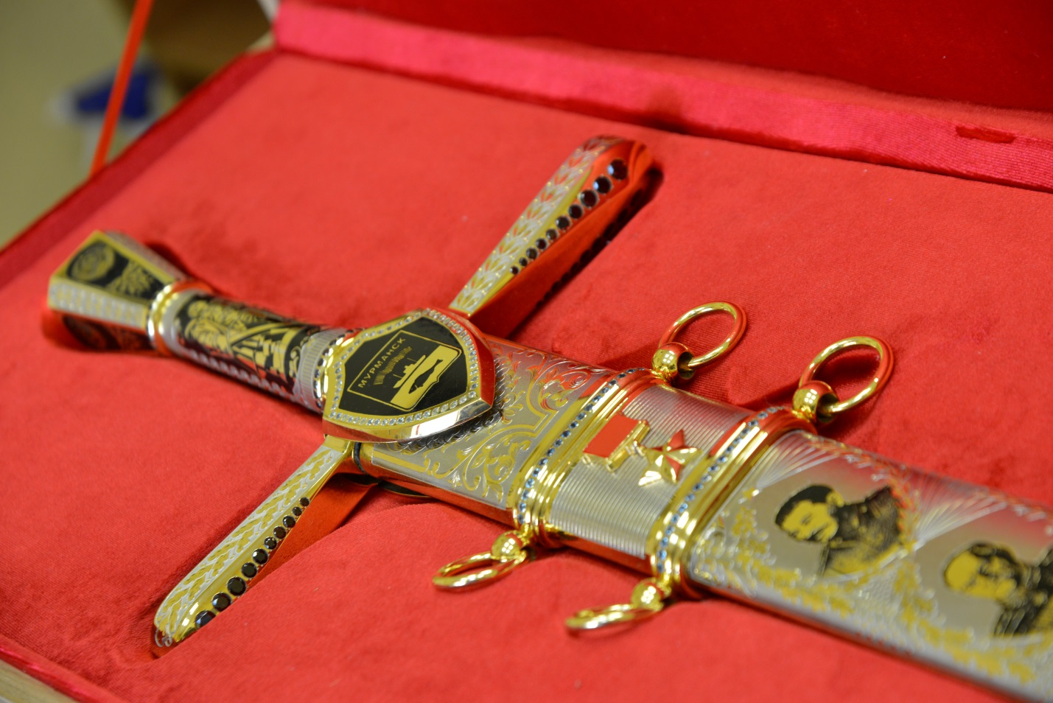

**City of Murmansk**

Budget revenues

Budget expenditures

**Actual value 2010:**

6 843,3 million rubles

6 949,4 million rubles

**Planned value 2011:**

7 694,2 million rubles

8 046,3 million rubles

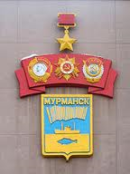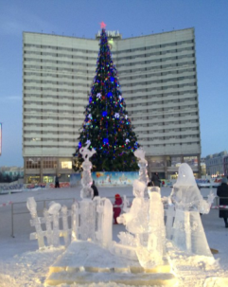

Доходы бюджета

Расходы бюджета

**Факт 2010**:

6 843,3 млн.руб.

6 949,4 млн.руб.

**План 2011**:

7 694,2 млн. руб.

8 046,3 млн.руб.

**Финансовая обеспеченность**

**Финансовая обеспеченность**

Доходы бюджета

Расходы бюджета

**Факт 2010**:

6 843,3 млн.руб.

6 949,4 млн.руб.

**План 2011**:

7 694,2 млн. руб.

8 046,3 млн.руб.

Total area – 16814 hа

(small hills landscape, 43% – urban forests, 0,5% of green areas of public use, 14 lakes, 8 streams, 1 river).

Distance to Moscow – 1967 km,

to St.Petersburg – 1448 km,

to the border with Norway- 200 km,

to the border with Finland (Lotta) - 231 km,

to the entrance to the Barents Sea – 50 km.

Population (01.01.2016) – 301572 people.

Internet address: Мурманск.рф



**Geographical and geopolitical location**

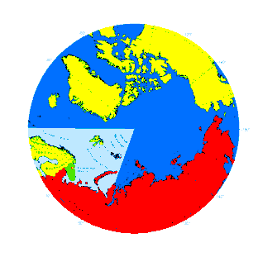

**Murmansk is the biggest city beyond the Polar Circle, the largest Russian see transport hub and fishing centre, which has a leading position in the region economics and remains its financial, business and cultural centre.**

**Main** [**competitive advantage**](file:///C:\Users\Medvedeva\AppData\Local\Microsoft\Windows\Temporary%20Internet%20Files\Content.Outlook\2PTPI7GO\Local%20Settings\Temp\Word_3)**s:**

* ice-free port with the outlet to the international shipping routes with the possibility of year-round navigation;
* centre of fishing industry, prospects for oil and gas exploration;
* location in close proximity to the developed Western countries;
* Murmansk is the member of the Barents Euro-Arctic Council.

|  |  |  |
| --- | --- | --- |
|  | 2014 | 2015 |
| per capita budget revenues | 32,65 thousand RUB | 36,6 thousand RUB |
| per capita budget expenditures | 34,36 thousand RUB | 37,3 thousand RUB |

**Financial coverage**

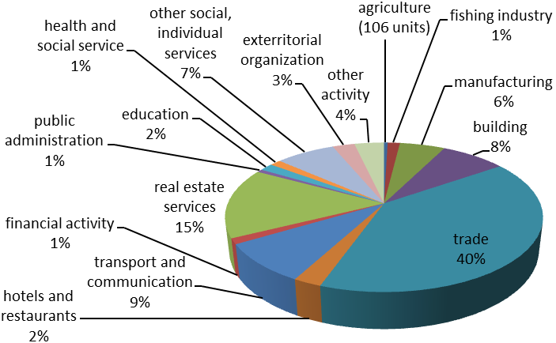

Number of economic entities (01.01.2016) — 23882 units.

**Structure of Economy**

**City of Murmansk**

**The city of Murmansk**

**Tourism potential**

Number of individual entrepreneurs (01.01.2016) — 7841 units.

**Cargo handling:**

JSC «Murmansk Sea Fishing Port»,

(transshipment of oil products and fish products),

OJSC «Murmansk Sea Commercial Port"

(coal freighters and container ships).

**Shipping:**

JSC «Murmansk Shipping Company»

(transportation of cargoes to the High North, including liquid bulk cargoes),

Murmansk Transport Branch of Norilsk Nickel.

**Passenger transport:**

Murmansk branch of the Oktyabrskaya

Railway, JSC «Electrotransport»,

JSC «Murmansk Shipping Company».

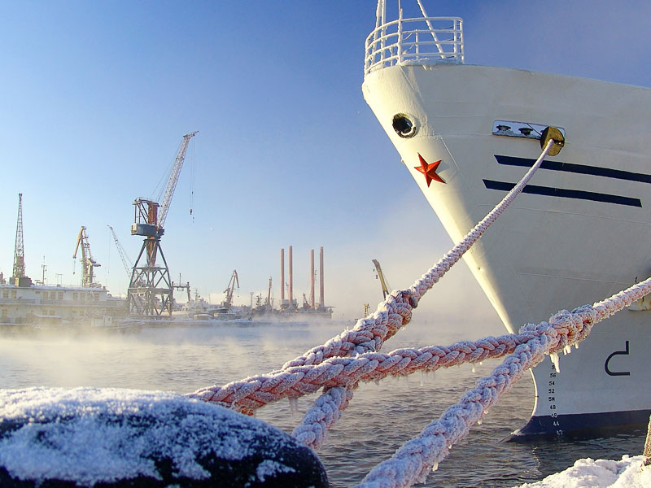

**Primary lands for building**

− passage Lyzhny, 14 - 0.6959 ha.  
− territory «Dolina Uyuta», 1 - 0.6528 ha.  
− 143 m to the north-east from Lomonosova st., 18 - 0.0850 ha.  
− 170 m to the north-west of Dostoevsky st., 19 - 0.2400 ha.  
− 46 m east of Trudovye reservy st., 8 - 0.0755 ha.  
− 76 m south of Pribrezhnaya st., 65 - 0,105 hectares.  
− passage Portovy - 0.0517 ha.  
− 45 m to the south-west of passage Portovy, 2 - 0,2369ga.  
− 37 m to the north-east from General Frolov st., 25/1 - 0.2120 ha.  
− 46 meters west of Domostroitelnay st., 21/3 - 0.2148 ha.  
− 7 m to the west of Vostochno-obyezdnaya doroga, 206B - 2.1730 ha.  
− 52 m to the southwest of Captain Kopytova st., 32 - 0.8109 ha.  
− 24 meters west of Starostina st., 30 - 0.7980 ha.

Total investment value on all funding sources – 53894,2 million RUB (57,1% - budget investments), 177,6 thousand RUB per 1 resident.

**Investment potential**

**City of Murmansk**

**Tourism potential**

**Cultural tourism**

**4 theatres**: Drama theatre, Theatre of the Northern Fleet, Puppet theatre, Arctic theatre.

**7 cinemas**: Murmansk cinema, Aurora cinema, Kronwerk cinema, E-Cinema «Odisseya-2010», Cinema 51, «Severnoye Sijanie», «Mirazh».

**Galleries:** «Prostranstvo», City Exhibition Hall

**Museums**: Art museum, Local History museum, Murmansk Oceanarium, Naval museum of the Northern Fleet, Arctic Exhibition Center on the Icebreaker «Lenin»

**Concert halls**: Philharmonic Hall,

Kirov Palace of Culture, Ice Palace.

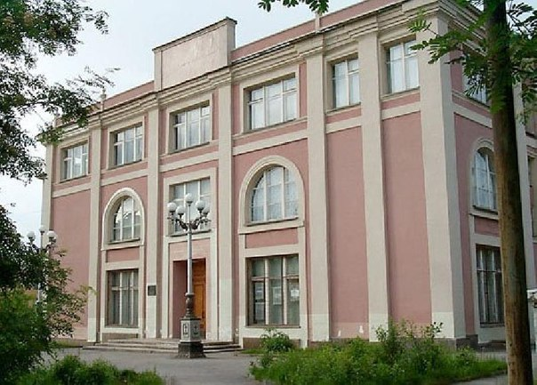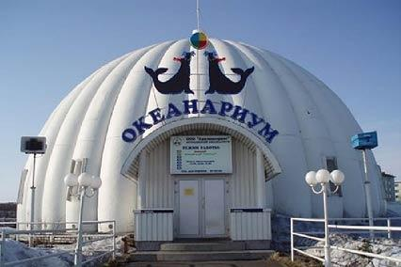

**Business tourism**

**Hotels and business centers:** «Arctic»,

«Meridian», «Park Inn by Radisson Polyarnie Zori», «Gubernskiy», «Moriak», «Fjord», «Sever», «Tamara» health resort

**Exhibition pavilion:** «MurmanEXPO»

**Events:** Murmansk International Business Week, Murmanexpo, Kola Partneriat, «SevTEK», «Zapolyarnaya Osen»

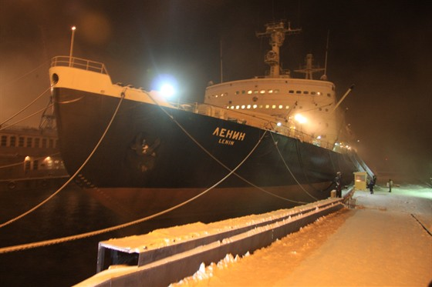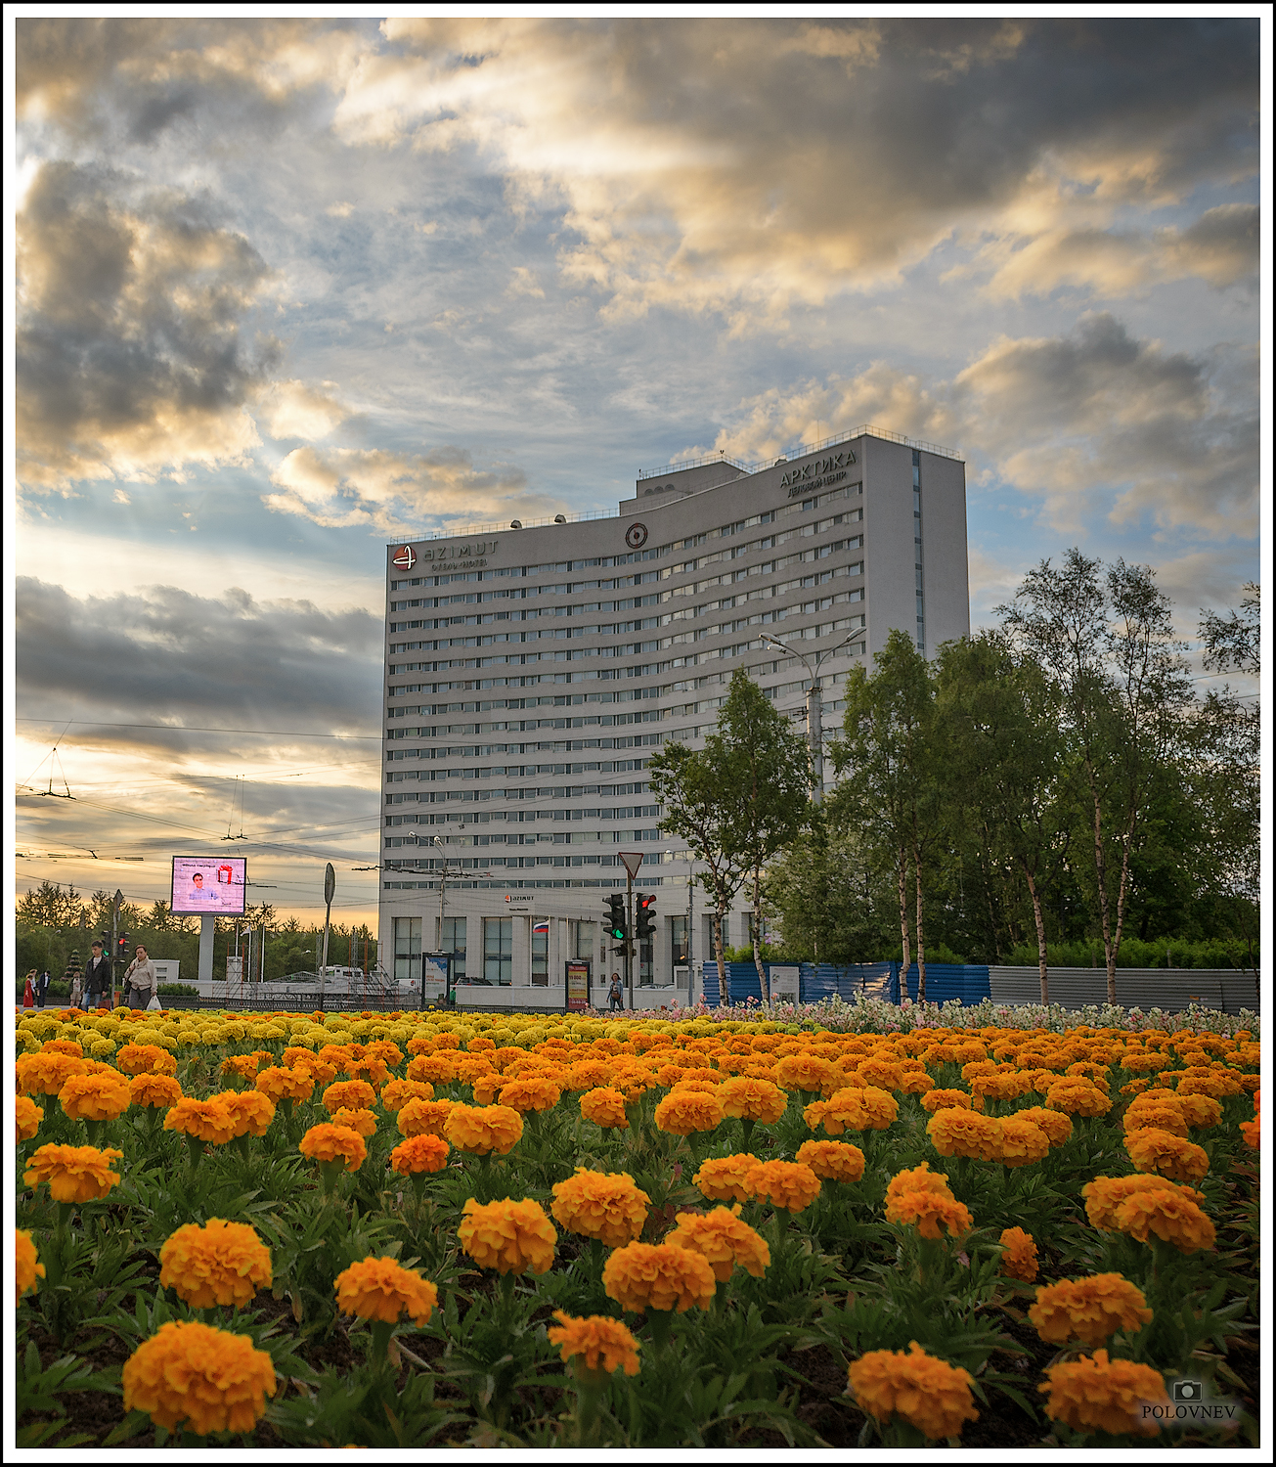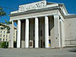

**Sports tourism**

Sports complex «[Dolina Uyuta](http://dolinayuta.ucoz.ru/" \t "_blank)», «Avangard».

Ice Palace.

2 stadiums.

3 trails for downhill skiing.

1 bowling center.

Covered skate park «Maximum».

North holiday and the Polar Olympics.

«The Murmansk Mile»/«Gulfstream», winter swimming, snowball fights.

Arctic Trophy, diving in Kola Bay and Barents sea, sea fishing, kiting, North Pole and Central Arctic voyages, amusement park, aqua park «Ogni Murmanska», Extreme park «Bodri Shar»

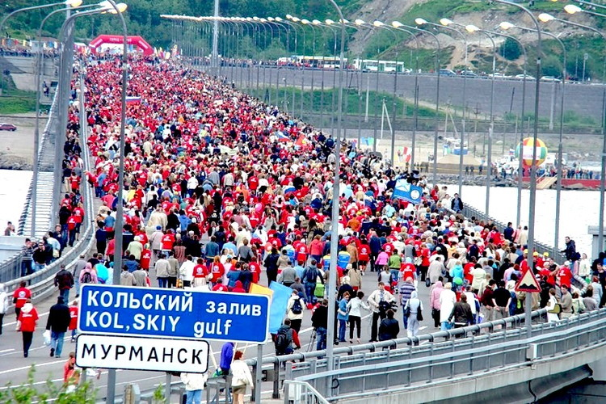

**Head of**

**the Municipality**

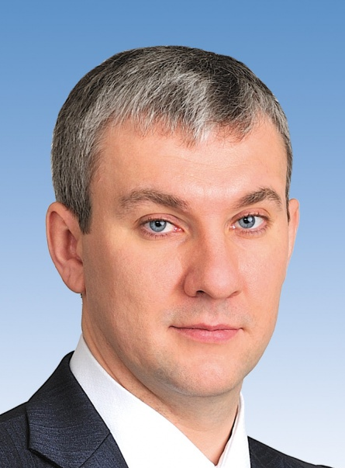

**Committee on Economic Development:**

8 (8152) **45-02-69, 45-85-60**

ekonomika@citymurmansk.ru

Investment portal

[**www.invest.murman.ru**](http://www.invest.murman.ru)

Touristic portal

[**www.tour.murman.ru**](http://www.tour.murman.ru)

SME information portal

[**www.mp.murman.ru**](http://www.mp.murman.ru)

**2016**

**Murmansk City Administration**

**Reception of the Head of the Administration:**

8 (8152) **45-55-72**

citymurmansk@citymurmansk.ru

**www. citymurmansk.ru**



**Reception of the Head of the Municipality:**

8 (8152) **45-64-64**

**www.vlast-murmanska.ru**

**Contact information:**

**75, Lenin Ave, Murmansk 183006 Russia**

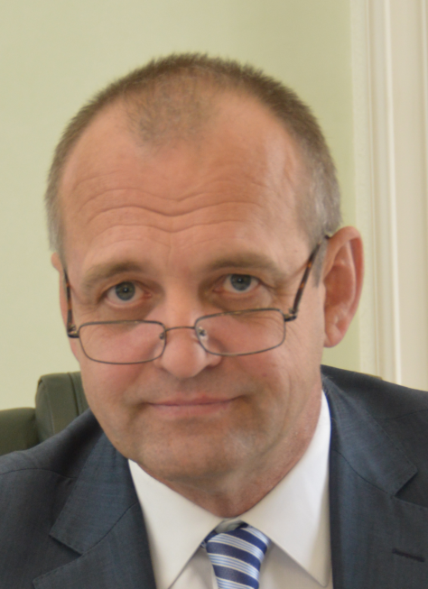

**Population on 01.01.2016:**

Working-age population – 182,6 thousand people.

Children (0-17 years) – 49,9 thousand people.

Population above working age – 69,1 thousand people.

Registered retired persons - 105,6 thousand people.

Average age of Murmansk residents is 39,13 years

(average age of men – 36,19 and women – 41,64).

**Demography in 2015**

birth rate – 12,36 children per 1000 inhabitants

mortality rate - 11,86 people per 1000 inhabitants,

migration loss rate – 12,6 people per 1000 inhabitants.

**Standards of living in 2015**

Population supplied:

housing - 23,8 sq. m per person;

preschool educational institutions – 799,51 beds per 1000 children of preschool age;

municipal libraries – 105,4%

Number of young and large families improved their housing with a social payment – 117 families;

Population regularly engaged in sport activities – 27,1%

Number of mass sports activities per year – 209 events

Number of children attending summer camps and holiday centers – 9398 persons

Number of employed underaged – 2329 persons

Unemployment rate - 1,1% of the total workforce.

Average monthly nominal wages – 53,2 thousand rubles.

Average size of pension – 16,6 thousand rubles.

Subsistence level – 13,6 thousand rubles.

**Labor and employment**

38,2% of the population are involved in the economic sector,

18,5% - small entrepreneurship;

32,4% of the population are engaged in the following spheres:

18,7% - in transport and communications;

15,5% - state service;

12,2% - in health and care;

12% - in the field of education;

9,6% - in trade and services;

6,4% - manufacturing industry;

6,1% - real estate activities;

4,4% - resource supply;

4,1% - in financial sphere;

3,5% - in fishing, fish farming

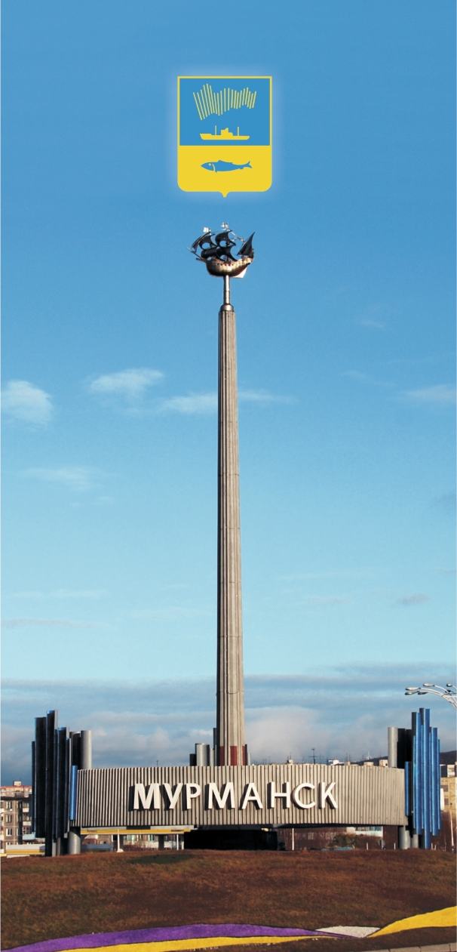

**City of Murmansk**

**Andrey Sysoev**

**Dmitry Filippov**

**Head of**

**the Administration**

**City of Murmansk**

**Social Indicators**



**Финансовая обеспеченность**

